**5G Protocols: F1AP, NGAP, and XnAP**

* **Introduction to 5G Protocols**
* **Protocols Covered**:
  + **F1AP**: Between gNB-CU and gNB-DU.
  + **NGAP**: Between gNB and 5G Core (AMF).
  + **XnAP**: Between neighboring gNBs.
* **F1AP Protocol**
* **Functions**:  F1AP is used for signaling between the gNB-CU (Central Unit) and gNB-DU (Distributed Unit) in 5G networks. It handles:
  + **UE Context Management**: Set up, modify, and release UE contexts.
  + **RRC Message Transfer**: Transfers RRC signaling messages.
  + **Resource Management**: Allocates and manages radio resources.
  + **Configuration Transfer**: Synchronizes configuration between CU and DU.
  + **Performance Measurement**: Collects and reports performance metrics.
  + **Supports Multi-Connectivity**: Enables connections across multiple cells for a single UE.
  + **Enables Distributed Processing**: Offloads processing to DU for improved efficiency.
  + **Facilitates Network Slicing**: Supports different network slices for various services.
* **Key Information Elements (IEs)**:
  + **UE Identity**: Unique identification for UEs.
  + **RRC Messages**: Encoded signaling messages exchanged between units.
  + **QoS Parameters**: Quality of Service requirements for data transmission.
  + **Transport Layer Address**: Network addresses for data transport.
  + **Cell Configuration**: Parameters for cell setup and management.
* **NGAP Protocol**
* **Functions**: NGAP is used for signaling between the gNB and the 5G Core (AMF - Access and Mobility Management Function). It handles:
  + **Initial UE Message Handling**: Manages initial registration and connection setup.
  + **UE Context Management**: Establishes, modifies, and releases UE contexts.
  + **Mobility Management**: Facilitates seamless handovers and mobility.
  + **Paging**: Manages paging procedures for locating UEs.
  + **Security Control**: Establishes security keys and parameters.
  + **PDU Session Management**: Handles setup and management of PDU sessions.
  + **Efficient Resource Allocation**: Prioritizes resources based on network policies.
  + **Seamless Integration**: Works with legacy systems for smooth transitions.
  + **Enhanced Security**: Provides robust security mechanisms for user data.
* **Key Information Elements (IEs)**:
  + **AMF UE NGAP ID**: Unique identifier for UE in the AMF.
  + **RAN UE NGAP ID**: Unique identifier for UE in the gNB.
  + **NAS Messages**: Encapsulated NAS signaling messages.
  + **Cause**: Indicates the reason for specific operations or events.
  + **PDUSessionResourceSetup**: Information for setting up PDU session resources.
* **XnAP Protocol**
* **Functions**:  XnAP is used for signaling between gNBs in 5G networks. It handles:
  + **Handover Management**: Supports preparation and execution of handovers.
  + **Load Balancing**: Distributes traffic load across gNBs.
  + **UE Context Transfer**: Transfers UE contexts between gNBs during handovers.
  + **Resource Status Reporting**: Shares information about resource usage and availability.
  + **Interference Management**: Coordinates interference detection and mitigation.
  + **Supports Dual Connectivity**: Allows UE to connect to multiple gNBs.
  + **Optimizes Network Efficiency**: Minimizes latency and maximizes throughput.
  + **Facilitates Inter-Node Communication**: Ensures consistent data flow and service continuity.
* **Key Information Elements (IEs)**:
  + **Global gNB ID**: Identifies the gNBs involved in communication.
  + **Xn Cause**: Describes the reason for initiating Xn procedures.
  + **UE History Information**: Tracks UE movements and handover history.
  + **Resource Status Information**: Details about current resource utilization.
  + **Handover Restriction List**: Specifies constraints on handovers between gNBs.
* **Summary of Protocols**
* **F1AP**: Manages signaling between gNB-CU and gNB-DU for resource allocation and RRC message transfer.
* **NGAP**: Handles signaling between gNB and 5G Core for UE context management, mobility, and security.
* **XnAP**: Facilitates coordination and handovers between gNBs for seamless mobility and resource optimization.

**Difference Between ARQ and HARQ**

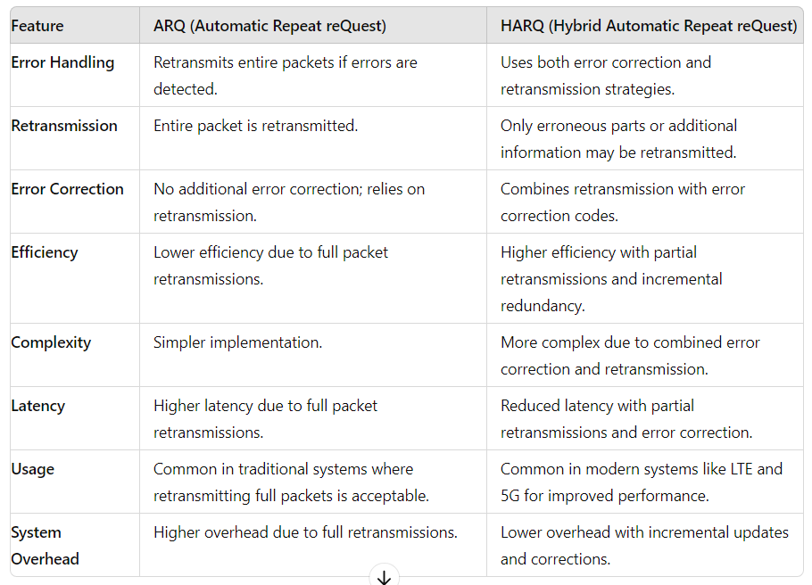

* **ARQ Types**:
* **Stop-and-Wait ARQ**: The sender waits for an acknowledgment (ACK) for each packet before sending the next one.
* **Go-Back-N ARQ**: The sender can send several packets before needing an ACK for the first one, but must retransmit all packets from a lost or erroneous one.
* **Selective Repeat ARQ**: Only the erroneous or lost packets are retransmitted, not all subsequent ones.
* **HARQ Types**:
* **Type I HARQ**: Simple combination of ARQ and FEC, where retransmissions are full packets with error correction codes.
* **Type II HARQ**: Uses incremental redundancy, where each retransmission adds new redundant information.
* **Soft Combining**: The receiver uses information from previous transmissions to improve error correction without requiring complete retransmission of packets.
* **Use Cases**:
* **ARQ**: Well-suited for applications requiring high reliability and where latency is less of a concern, such as file transfers over a stable network.
* **HARQ**: Essential for modern wireless systems, where maintaining throughput and minimizing latency are crucial despite high error rates.
* **Conclusion**:
* ARQ provides a straightforward method for error correction but can be inefficient in high-noise environments due to frequent retransmissions.
* HARQ enhances efficiency and throughput by using error correction codes and soft combining techniques, making it ideal for wireless communications where channel conditions vary rapidly.

**PDCP and SDAP Protocols in 5G**

* **Introduction to PDCP and SDAP**
  + **PDCP (Packet Data Convergence Protocol)**: Handles data packet transmission between the user equipment (UE) and the network.
  + **SDAP (Service Data Adaptation Protocol)**: Manages QoS and service data flows for different services and applications.
* **PDCP (Packet Data Convergence Protocol)**
* **Functions**:
* **Data Transfer**: Handles both user plane and control plane data.
  + **Header Compression**: Reduces the size of IP headers for efficient transmission.
  + **Encryption**: Provides data security by encrypting user data.
  + **Integrity Protection**: Ensures data integrity by protecting against tampering.
  + **Reordering**: Ensures packets are delivered in the correct order.
  + **Duplicate Detection**: Detects and handles duplicate packets to avoid data redundancy.
* **Entities**:
  + **PDCP Entity**: Responsible for processing user plane data and signaling data.
  + **RLC (Radio Link Control)**: Interacts with PDCP to handle data transfer between the UE and eNodeB/gNB.
  + **GTP-U (GPRS Tunneling Protocol - User Plane)**: Encapsulates PDCP data for transmission across the core network.
* **Key Information Elements (IEs)**:
  + **Sequence Number**: Used for reordering and duplicate detection.
  + **Ciphering Key**: For encrypting user data.
  + **Integrity Key**: For integrity protection of data.
* **SDAP (Service Data Adaptation Protocol)**
* **Functions**:
  + **QoS Flow Mapping**: Maps user data to different QoS flows based on service requirements.
  + **Packet Scheduling**: Schedules data packets according to QoS requirements and priority.
  + **Traffic Management**: Manages traffic to ensure efficient data flow and minimal congestion.
  + **Bearer Management**: Handles the creation, modification, and deletion of bearers for different services.
* **Entities**:
  + **SDAP Entity**: Each SDAP entity is associated with a PDU session and handles the mapping of QoS flows to DRBs.
  + **PDCP**: Interfaces with SDAP to receive data packets with applied QoS.
  + **RLC**: Interfaces with SDAP for packet scheduling and bearer management.
  + **gNB/NG-RAN**: Implements SDAP functions in the 5G network.
* **Key Information Elements (IEs)**:
  + **QoS Flow Identifier**: Identifies the QoS flow for different types of data.
  + **Bearer Context**: Information about the bearer and its configuration.
  + **Traffic Class**: Defines the priority and type of traffic for scheduling.
* **Comparison of PDCP and SDAP**
* **PDCP**:
  + **Focus**: Data transfer efficiency, security, and integrity.
  + **Functions**: Header compression, encryption, reordering.
  + **Layer**: Operates above the RLC layer.
* **SDAP**:
  + **Focus**: QoS management and service flow adaptation.
  + **Functions**: QoS flow mapping, traffic management, bearer management.
  + **Layer**: Operates below the PDCP layer but above the RLC layer.
* **Summary**
* **PDCP**: Focuses on header compression, encryption, and data integrity.
* **SDAP**: Manages QoS, traffic, and bearer management.